**Grammar of Graphics to understand the dimensions of visuals.**

**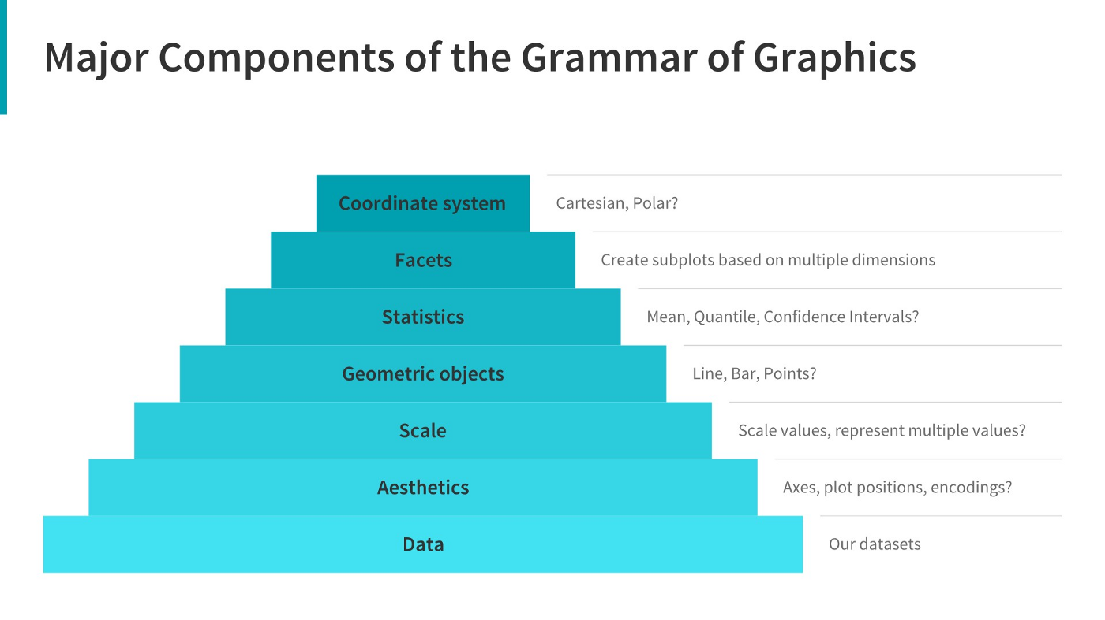**

**[[](https://towardsdatascience.com/a-comprehensive-guide-to-the-grammar-of-graphics-for-effective-visualization-of-multi-dimensional-1f92b4ed4149)](https://towardsdatascience.com/a-comprehensive-guide-to-the-grammar-of-graphics-for-effective-visualization-of-multi-dimensional-1f92b4ed4149" \t "_blank)**

**[A Comprehensive Guide to the Grammar of Graphics](https://towardsdatascience.com/a-comprehensive-guide-to-the-grammar-of-graphics-for-effective-visualization-of-multi-dimensional-1f92b4ed4149" \t "_blank)**

**[Click to view website →](https://towardsdatascience.com/a-comprehensive-guide-to-the-grammar-of-graphics-for-effective-visualization-of-multi-dimensional-1f92b4ed4149" \t "_blank)**

**[[](https://www.analyticsvidhya.com/blog/2021/09/how-to-choose-the-right-chart-for-data-visualization/)](https://www.analyticsvidhya.com/blog/2021/09/how-to-choose-the-right-chart-for-data-visualization/" \t "_blank)**

**[How to Choose the Right Chart for Data Visualisation](https://www.analyticsvidhya.com/blog/2021/09/how-to-choose-the-right-chart-for-data-visualization/" \t "_blank)**

**[Click to view website →](https://www.analyticsvidhya.com/blog/2021/09/how-to-choose-the-right-chart-for-data-visualization/" \t "_blank)**

**Choosing right charts based upon need such as Comparison, Distribution, Relationship, and Composition.**

**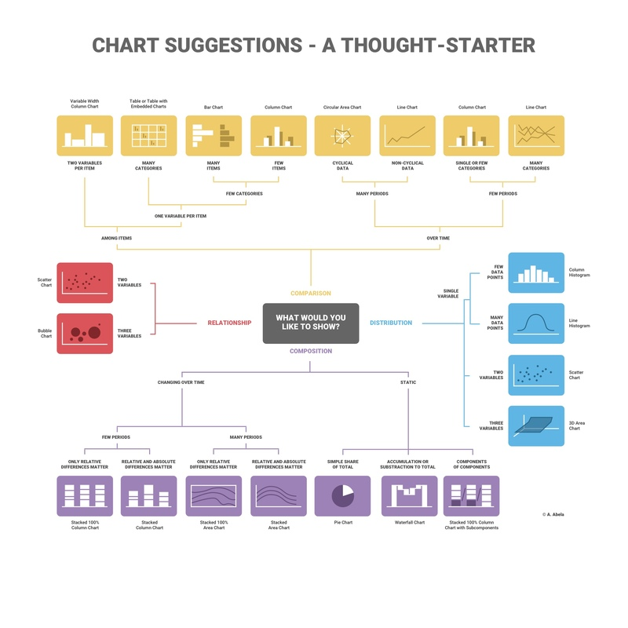**

**[[](https://infogram.com/page/choose-the-right-chart-data-visualization)](https://infogram.com/page/choose-the-right-chart-data-visualization" \t "_blank)**

**[How to Choose the Right Chart for Your Data](https://infogram.com/page/choose-the-right-chart-data-visualization" \t "_blank)**

**[Click to view website →](https://infogram.com/page/choose-the-right-chart-data-visualization" \t "_blank)**

**Additional Resources:**

**[[](https://towardsdatascience.com/ultimate-guide-to-choosing-the-right-visual-2a77aa8eec08)](https://towardsdatascience.com/ultimate-guide-to-choosing-the-right-visual-2a77aa8eec08" \t "_blank)**

**[Ultimate Guide to Choosing the Right Visual](https://towardsdatascience.com/ultimate-guide-to-choosing-the-right-visual-2a77aa8eec08" \t "_blank)**

**[Click to view website →](https://towardsdatascience.com/ultimate-guide-to-choosing-the-right-visual-2a77aa8eec08" \t "_blank)**

**[[](https://chartio.com/learn/charts/how-to-choose-data-visualization/)](https://chartio.com/learn/charts/how-to-choose-data-visualization/" \t "_blank)**

**[How to Choose the Right Data Visualisation](https://chartio.com/learn/charts/how-to-choose-data-visualization/" \t "_blank)**

**[Click to view website →](https://chartio.com/learn/charts/how-to-choose-data-visualization/" \t "_blank)**

**[[](https://www.tableau.com/learn/whitepapers/which-chart-or-graph-is-right-for-you)](https://www.tableau.com/learn/whitepapers/which-chart-or-graph-is-right-for-you" \t "_blank)**

**[Which Type of Chart or Graph is Right for You?](https://www.tableau.com/learn/whitepapers/which-chart-or-graph-is-right-for-you" \t "_blank)**

**[Click to view website →](https://www.tableau.com/learn/whitepapers/which-chart-or-graph-is-right-for-you" \t "_blank)**